Readme for Windows Driver Kit 8.0

General
This package contains an early release of the Windows Driver Kit (WDK) for Windows 8. The WDK requires the corresponding Software Development Kit (SDK) to be installed. This package contains compilers and WDK tools for driver development, however future releases will not ship compilers. This kit is being delivered “as is” and may have content that is missing or does not work correctly. It may also contain content that will be removed in a later release.
This document details the content for the WDK you have received through connect.microsoft.com. Please review this readme for notes associated with this build.

Installing the Windows Driver Kit
- For proper installation of the Windows Driver Kit (WDK), you must have Visual Studio 10 Professional or higher installed.
- If you have a previous version of the WDK 8.0 installed, please uninstall all components of it using Add/Remove Programs in Control Panel.
- Installing the WDK is supported on Windows Server 2008, Windows 7, and Windows 8.
- For proper installation, unzip the 8027_ SDK_WDK.zip file to your hard drive.
- Run SDK\sdksetup.exe by right-clicking and selecting “Run as administrator”
- Run WDK\wdksetup.exe by right-clicking and selecting “Run as administrator”
- From an elevated CMD window, run cscript managed.vbs and reboot the system

Major Changes in the Windows Driver Kit
- WDK is moving
  - \Program Files\Windows Kits\8.0\... or \Program Files (x86)\Windows Kits\8.0 (depending on whether you are installing on a 32-bit or 64-bit version of Windows)
  - Common kit directory structure – common build environment with SDK
  - Both SDK and WDK kit files only installed under one root
- Driver Development is moving to Visual Studio:
  - MSBuild.exe is used to build drivers, build.exe is deprecated
  - .VCXProj files are used to build drivers, sources and makefile.inc files are deprecated
  - Templates for specific device types
  - Driver testing exposed in VS

Documentation will no longer ship with the WDK. Documentation is available from MSDN.

How to Use the Windows Driver Kit
- Create new project using the “New Project” dialog in VS:
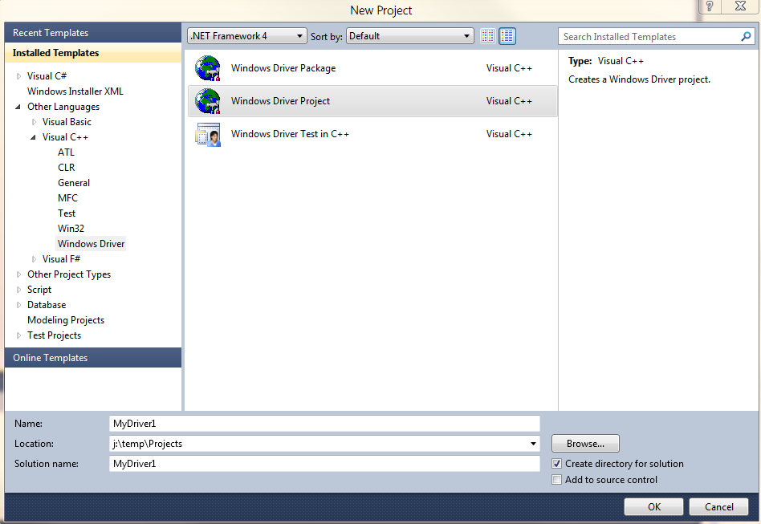
- Convert your existing drivers using the Nmake2Msbuild.exe (see below) – this will create a .vcxproj file based on your current sources file. The .vcxproj file is used to build your driver in VS.
- Convert samples and build them

Command Line Builds
If you have a .vcxproj file, you can build your driver from the command line using MSbuild.exe. Use the Visual Studio 10 start menu shortcut to open a BE window. Go to the folder that contains your driver project and issue the command: msbuild.exe <your project>.vcxproj.

PreFast Added to WDK
In this release, PreFast (OACR) has been added to the WDK. For information concerning PreFast, please read the PreFast Readme provided with this release.

References
For more detailed information regarding migrating your existing projects to the new build environment and getting started with customizing the new build environment settings, please refer to the separate documents provided on those topics. We have also enclosed a document that lists the known issues for this particular release.

Conversion Tool
Nmake2Msbuild.exe is a tool that creates VCxproj files for existing driver projects and application samples from the existing sources and makefile files. Converting these driver projects into a Visual Studio project enables you to modify and maintain existing source code, and to compile by using the new build tool, MSBuild.exe. The nmake2msbuild.exe tool is available under the bin directory of the WDK Installation folder. Eg.: C:\Program Files (x86)\Windows Kits\8.0\bin\x86\nmake2msbuild.exe.

